# **Investigating the Shooting-Free Weekend in New York City: Consequence or Coincidence?**

Rachel C. Weber, MPH Candidate

# **Background**

New York City has a tumultuous history of gun violence. After a significant drop in gun violence in the 1990’s, New York City has made steady progress in reducing shooting incidences in the new millennium[1]. The New York Times reported in August 2019 that gun violence is at a two-decade low for the city[2]. Many researchers cite the state’s strong gun control laws and progressive police training as the reason for New York’s improvement.[3] Along with state-level regulation, the national culture around gun ownership and resulting violence has been in major flux. Though New York City’s worst years of gun violence are in the past, growing national incidence of mass shootings has brought community activists to action.

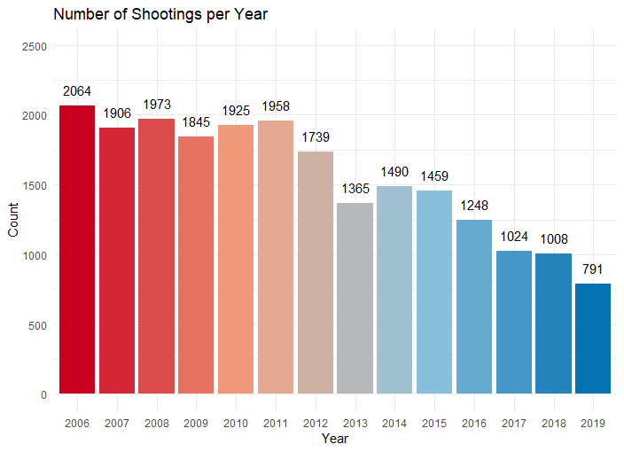

*Figure 1: Histogram of Number of Shootings in NYC per year (2006-2019)*

Following the Sandy-Hook shooting in December 2012 and the December 24th Webster shooting, New York passed the Secure Ammunition and Firearms Enforcement Act (SAFE Act) which contains several firearms regulations. These include broader definitions of ‘assault style weapons’, prohibitions on high capacity magazines, mandated background checks, and safe storage provisions. In 2010, New York City implemented Chicago’s Cure Violence public health model to use community outreach as a means of curbing gun violence. As of 2017 there were 18 active Cure Violence programs around the city working to ‘denormalize’ gun violence[4].

The first shooting free weekend (Friday, Saturday, Sunday) NYC has had in decades happened in Mid-October 2018. This event made national news with the exclamations of ‘amazing’ and ‘a milestone’[5]. But the crux of the matter is this: was this event a very lucky run or a consequence of legislation and community action? This analysis will build an interrupted time series negative binomial model to ascertain the odds of a given day being shooting-free. We will then apply standard probability theory to estimate the probability of a consecutive Friday-Saturday-Sunday being shooting-free.

**Methods**

Data are supplied by NYC Open Data. The dataset spans years 2006 through 2019. Each row contains the time and date of a shooting, the location (precinct and latitude/longitude), and perpetrator/victim demographic information (including sex, race, and age group).

Data is manually extracted every quarter and reviewed by the Office of Management Analysis and Planning. Data is intended for public use to, “explore the nature of shooting/criminal activity” in NYC.

All analyses will be performed in R version XX.XX. Date and time data were all that were needed for analysis as adjustment for precinct/location was beyond the scope of this study. Date and time fields have zero missingness. Days without shootings were not present in the dataset. These days were added as new, empty rows to allow for counts and visualizations of such days. Additionally, variables for season and year were added using the date variable. It has been documented that shooting incidence changes depending on time of year; rising in the summer and falling in the winter[6],[7]. The extent to which this data agrees with this understanding can be seen in the shooting incidence graph in the Appendix (graph A). Month was included as a factor variable to accommodate these temporal fluctuations. Finally, an interrupted time series variable for pre/post SAFE act implementation was developed to understand the effect this new legislation had on incidence of gun violence at the level of number of shootings per day.

Univariate modeling was conducted to identify variables associated with changes in shootings-per-day. Only variables found to be statistically significant (p < .05) in univariate analysis were used in multivariable modeling.

# **Findings**

The interrupted time series negative binomial model suggested that Month, day of the week, and SAFE act passage were significantly associated with the number of shootings expected on a given day (Table 1). The intercept represents a Friday in January, pre-intervention.

|  |  |  |  |
| --- | --- | --- | --- |
| Variable | Estimate | P-Value | 95% Confidence Interval |
| Intercept | 3.88 | <.001 | (3.53, 4.28) |
| Baseline Slope | 0.98 | 0.009 | (0.97,1) |
| Day (Monday) | 1.06 | 0.133 | (0.98, 1.14) |
| Day (Tuesday) | 0.86 | <.001 | (0.8, 0.93) |
| Day (Wednesday) | 0.82 | <.001 | (0.76, 0.88) |
| Day (Thursday) | 0.81 | <.001 | (0.75, 0.87) |
| Day (Saturday) | 1.44 | <.001 | (1.35, 1.55) |
| Day (Sunday) | 1.53 | <.001 | (1.42, 1.64) |
| Pre-Post SAFE Act | 0.86 | <.001 | (0.8, 0.93) |
| Intervention Slope Change | 0.94 | <.001 | (0.92, 0.96) |
| Month (February) | 0.85 | 0.002 | (0.77, 0.94) |
| Month (March) | 0.95 | 0.291 | (0.86, 1.05) |
| Month (April) | 1.16 | 0.003 | (1.05, 1.28) |
| Month (May) | 1.46 | <.001 | (1.32, 1.6) |
| Month (June) | 1.61 | <.001 | (1.47, 1.77) |
| Month (July) | 1.76 | <.001 | (1.61, 1.93) |
| Month (August) | 1.76 | <.001 | (1.6, 1.92) |
| Month (September) | 1.5 | <.001 | (1.37, 1.65) |
| Month (October) | 1.35 | <.001 | (1.22, 1.48) |
| Month (November) | 1.17 | 0.002 | (1.06, 1.29) |
| Month (December) | 1.17 | 0.001 | (1.06, 1.29) |

Month Table:

|  |  |  |  |
| --- | --- | --- | --- |
| Variable | Estimate | P-Value | 95% CI |
| Intercept | 312.67 | <.001 | (121.31, 145.09) |
| Baseline Slope | 0.999 | 0.028 | (1,1) |
| Pre-Post SAFE Act | 0.875 | 0.002 | (0.8, 0.95) |
| Slope Change | 0.995 | <.001 | (0.99, 1) |
| Month (February) | 0.792 | <.001 | (0.71, 0.88) |
| Month (March) | 0.947 | 0.312 | (0.85, 1.05) |
| Month (April) | 1.105 | 0.061 | (1, 1.23) |
| Month (May) | 1.416 | <.001 | (1.28, 1.57) |
| Month (June) | 1.529 | <.001 | (1.38, 1.69) |
| Month (July) | 1.71 | <.001 | (1.55, 1.89) |
| Month (August) | 1.718 | <.001 | (1.55, 1.9) |
| Month (September) | 1.421 | <.001 | (1.28, 1.57) |
| Month (October) | 1.314 | <.001 | (1.18, 1.46) |
| Month (November) | 1.113 | 0.049 | (1, 1.24) |
| Month (December) | 1.158 | 0.007 | (1.04, 1.29) |

1. Messner, S. F., Galea, S., Tardiff, K. J., Tracy, M., Bucciarelli, A., Piper, T. M., ... & Vlahov, D. (2007). Policing, drugs, and the homicide decline in New York City in the 1990s. *Criminology*, *45*(2), 385-414.
2. https://www.nytimes.com/2019/08/06/nyregion/newyorktoday/nyc-gun-violence.html
3. vpc.org/press/states-with-weak-gun-laws-and-higher-gun-ownership-lead-nation-in-gun-deaths-new-data-for-2015-confirms/
4. https://johnjayrec.nyc/2017/10/02/cvinsobronxeastny/
5. https://www.foxnews.com/us/new-york-citys-weekend-free-of-shootings-is-first-in-decades
6. Larsen, D. A., Lane, S., Jennings-Bey, T., Haygood-El, A., Brundage, K., & Rubinstein, R. A. (2017). Spatio-temporal patterns of gun violence in Syracuse, New York 2009-2015. *PloS one*, *12*(3).
7. Lauritsen, J. L., & White, N. (2014). *Seasonal patterns in criminal victimization trends*. US Department of Justice, Office of Justice Programs, Bureau of Justice Statistics.